EX. NO: | PORTFOLIO WEBSITE USING REACT JS
DATE: | PORTFOLIO WEBSITE USING REACT JS

AIM:
To develop a personal portfolio website using React JS that displays personal details, skills, projects, and contact information for potential recruiters.

ALGORITHM:

STEP 1: Create a new React JS project using Vite.
STEP 2: Open the project in VS Code.
STEP 3: Create the portfolio layout using React components.
STEP 4: Add sections such as About, Skills, Projects, and Contact.
STEP 5: Use JSX to display personal information.
STEP 6: Apply CSS styling for attractive user interface.
STEP 7: Add responsive design for better viewing experience.
STEP 8: Import CSS file into React component.
STEP 9: Run the application using npm run dev.
STEP 10: Display the portfolio website in the browser.

PROGRAM CODE:

App.jsx
import "./App.css";

function App() {
return (
<div className="container">
<header className="hero">
<img
src="https://cdn-icons-png.flaticon.com/512/3135/3135715.png"
alt="profile"
className="profile"
/>

<h1>PRANAV J</h1>

<p className="role">
MCA Student | Data Engineer Aspirant
</p>

<a href="#contact" className="btn">
Hire Me
</a>
</header>

<section className="card">
<h2>About Me</h2>

<p>
Passionate MCA student with strong interest in
Data Engineering, IoT, Web Development,
and Machine Learning.
</p>
</section>

<section className="card">
<h2>Skills</h2>

<div className="skills">
<span>Java</span>
<span>Python</span>
<span>React JS</span>
<span>MySQL</span>
<span>Machine Learning</span>
<span>IoT</span>
</div>
</section>

<section className="card">
<h2>Projects</h2>

<ul>
<li>Pneumonia Detection using Deep Learning</li>
<li>Smart Parking System using IoT</li>
<li>Credit Card Fraud Detection</li>
<li>React Login and Calculator Apps</li>
</ul>
</section>

<section className="card" id="contact">
<h2>Contact</h2>

<p>Email: messi10@gmail.com</p>
<p>Phone: +91 9876543210</p>
<p>Location: Tamil Nadu, India</p>
</section>
</div>
);
}

export default App;
App.css
* {
margin: 0;
padding: 0;
box-sizing: border-box;
}

body {
font-family: Arial, sans-serif;
background: linear-gradient(135deg, #141e30, #243b55);
color: white;
}

.container {
width: 90%;
max-width: 1000px;
margin: auto;
padding: 30px 0;
}

.hero {
text-align: center;
padding: 40px 20px;
}

.profile {
width: 140px;
height: 140px;
border-radius: 50%;
border: 4px solid white;
margin-bottom: 20px;
}

.hero h1 {
font-size: 40px;
}

.role {
margin-top: 10px;
font-size: 18px;
opacity: 0.9;
}

.btn {
display: inline-block;
margin-top: 20px;
padding: 12px 25px;
background: #00c853;
color: white;
text-decoration: none;
border-radius: 10px;
font-weight: bold;
}

.card {
background: rgba(255, 255, 255, 0.08);
padding: 25px;
margin-top: 25px;
border-radius: 20px;
backdrop-filter: blur(10px);
}

.card h2 {
margin-bottom: 15px;
color: #00e5ff;
}

.skills {
display: flex;
flex-wrap: wrap;
gap: 15px;
}

.skills span {
background: #00c853;
padding: 10px 18px;
border-radius: 25px;
font-weight: bold;
}

ul {
padding-left: 20px;
}

ul li {
margin-bottom: 10px;
}

main.jsx
import { StrictMode } from 'react'
import { createRoot } from 'react-dom/client'
import './index.css'
import App from './App.jsx'
createRoot(document.getElementById('root')).render(
<StrictMode>
<App />
</StrictMode>,
)
OUTPUT:
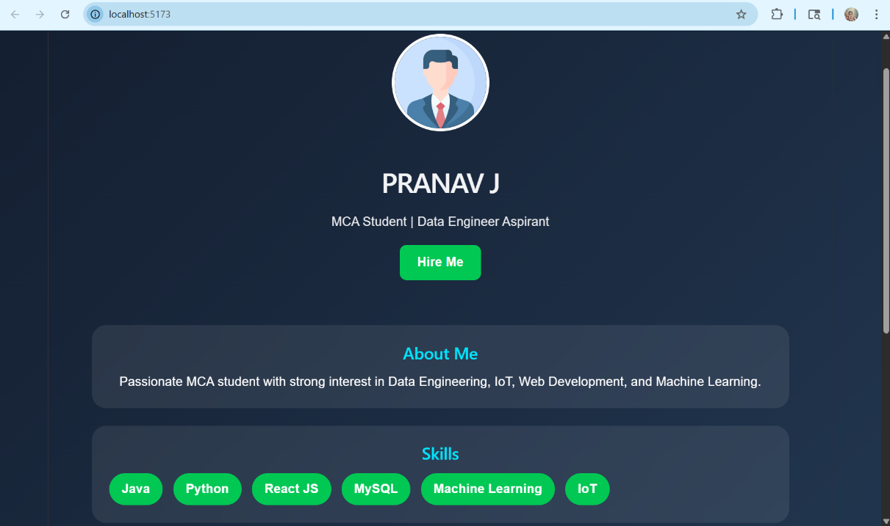

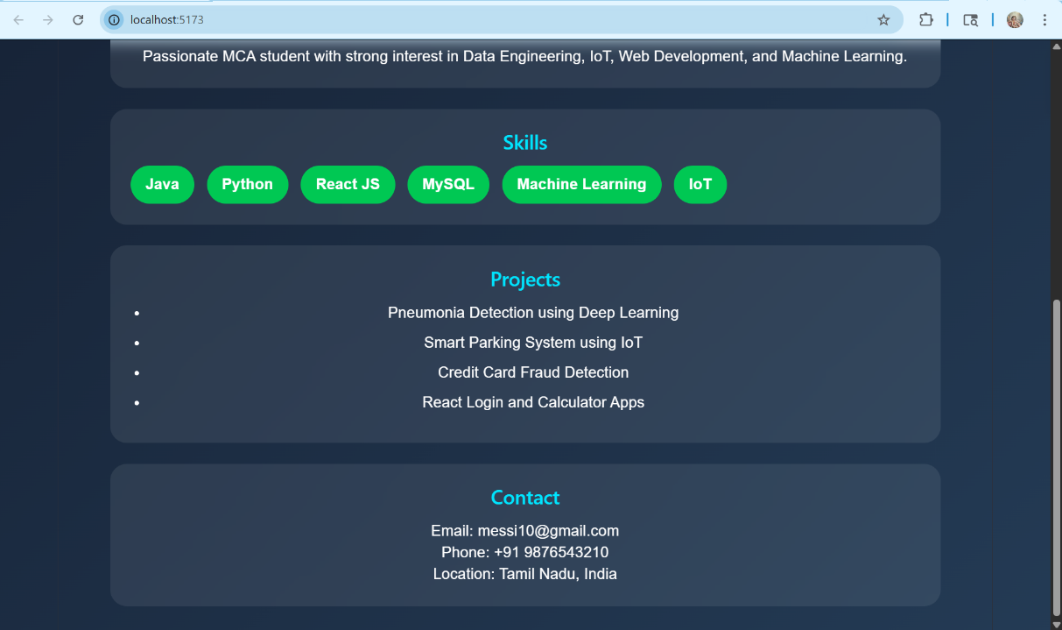

RESULT:
Thus, the portfolio website using React JS was developed successfully and displayed personal details for potential recruiters.

